**A MINI-PROJECT REPORT ON**

**OBJECT TRACKING ROBOT USING ARDUINO**

SUBMITTED TO THE SAVITRIBAI PHULE PUNE UNIVERSITY, PUNE IN THE PARTIAL FULFILLMENT FOR THE AWARD OF THE DEGREE

**OF**

**THIRD YEAR OF ENGINEERING IN**

**ELECTRONICS AND TELECOMMUNICATION**

# BY

**SIDDHI MUDGAL Exam.No. T190363263 PRASAD NANAWARE Exam.No. T190363274**

**UNDER THE GUIDANCE OF Mrs. Smita Bhosale**



**DEPARTMENT OF ELECTRONICS AND TELECOMMUNICATIONENGG**. **STES’S**

**SMT. KASHIBAI NAVALE COLLEGE OF ENGINEERING VADGAON BK., OFF.SINHGAD ROAD**

**PUNE 411041**

**2023– 2024**



**CERTIFICATE**

This is to certify that the mini project report entitled

“**OBJECT TRACKING ROBOT USING ARDUINO**”

**Submitted by**

SIDDHI MUDGAL Exam No. T190363263

PRASAD NANAWARE Exam No. T190363274

is a bonafide work carried out by them under the supervision of Prof. A.N.Kulkarni and it is approved for the partial fulfillment of the requirement of Savitribai Phule Pune University for the award of the Degree of Third Year of Engineering (Electronics and Telecommunication Engineering).

This Mini-project report has not been earlier submitted to any other Institute or University for the award of any degree or diploma*.*

|  |  |
| --- | --- |
| Mrs. Smita Bhosale | Mrs. S.S. Jahagirdar/ Mrs. K. A. Pujari |
| **Guide, Department of E & TC** | Mini-Project Coordinator |
|  | **Department of E&TC** |

|  |  |
| --- | --- |
| Dr. S.K. Jagtap | Dr. A.V. Deshpande |
| **Head** | **Principal** |
| **Department of E&TC** | **S.K.N.C.O.E, Pune-41** |

Place: Pune Date

# ACKNOWLEDGEMENT

I take this opportunity to thank all those who have contributed to the successful completion of this Mini Project. I would like to express my sincere thanks to my guide Prof. Smita Bhosale who has encouraged us to work and provided valuable guidance whenever required. We express our immense pleasure and thankfulness to mini project coordinators Ms. S.S.Jahgirdar & Ms. K.A.Pujari who guided us on every possible stage. We also extend our gratitude to Dr. S.K. Jagtap (HOD OF ENTC DEPARTMENT) who has provided facilities to explore this subject with more enthusiasm. We express our immense pleasure and thankfulness to Dr. A.V. Deshpande (Principle SKNCOE) has provided facilities to explore this subject with more enthusiasm. We also like to thank all the teaching and non-teaching staff for their immense support and their cooperation.

|  |  |  |
| --- | --- | --- |
|  | **CONTENTS** |  |
| CERTIFICATE |  | I |
| ACKNOWLEDGEMENT |  | II |
| INDEX |  | III |
| LIST OF FIGURES |  | IV |
| LIST OF TABLES |  | V |
|  | **INDEX** |  |

|  |  |  |
| --- | --- | --- |
| **CHAPTER** | **TITLE** | **PAGE NO.** |
| **1** | **INTRODUCTION** | 6 |
| 1.1 | BACKGROUND | 6 |
| 1.2 | RELEVANCE | 6 |
| 1.3 | OBJECTIVE | 6 |
| 1.4 | SUMMARY | 7 |
| **2** | **LITERATURE SURVEY** | 8 |
| **2.1** | INTRODUCTION | 8 |
| **2.2** | REFERENCE PAPER | 8 |
| **2.3** | SUMMARY | 9 |
| **3** | **DESIGN AND DRAWING** | 10 |
| **3.1** | BLOCK DIAGRAM | 10 |
| **3.2** | BLOCK DIAGRAM DESCRIPTION | 10 |
| **3.3** | COMPONENTS USED | 11 |
| **4** | **IMPLEMENTATION AND RESULTS** | 15 |
| **4.1** | HARDWARE | 15 |
| **4.2** | HARDWARE DETAILS | 15 |
| **4.3** | SUMMARY | 16 |
| **5** | **CONCLUSIONS** | 17 |
| **6** | **REFERENCES** | 18 |

**LIST OF FIGURES**

|  |  |
| --- | --- |
| **FIGURE NO.** | **DIAGRAM PAGE NO.** |
| FIGURE 1 | Block diagram of Object Tracking Robot 10 |
| FIGURE 2 | Ultrasonic Sensor 11 |
| FIGURE 3 | DC Motor 12 |
| FIGURE 4 | Server Motor 12 |
| FIGURE 5 | Battery 13 |
| FIGURE 6 | Arduino UNO 13 |
| FIGURE 7 | Motor Driver 14 |
| FIGURE 8 | Result of Object Tracking Robot 15 |
|  |  |

**CHAPTER 1. INTRODUCTION**

* 1. BACKGROUND:

Disasters can disturb economic and social balance of the civilization. Natural disasters occur frequently now-a-days. Many human beings are victims of such disasters. Disasters can be either natural or human induced disasters. Natural calamities include floods, storms, cyclones, bush fires, and earthquakes. Human induced disasters are transportation accidents, industrial accidents and major fires. During such disasters, in order to prevent loss of life various essential services (like fire fighters, medical Personnel, police) are deployed.

* 1. RELEVANCE:

1. In most of the disasters and natural calamities, the rescue team faced many problems in searching people which were in concern. Some lose their lives because of this. Generally, rescue people cannot enter into some parts/places of the affected areas. All these tasks are done mostly by people and dogs.
2. To avoid any further losses a robotic system can be employed for providing alert of human being. Wireless robotics is one of the evolving fields of application, where different technology is used. It is an application where the concept of embedded processor to wireless communication is being used for a practical application such as search and rescue mission.
   1. OBJECTIVES:

* To develop a color-based object tracking system using the Arduino.
* To implement computer vision techniques to detect and follow objects of specific colors.
* To create a user-friendly interface for color selection and adjustments.
* To enable the robot to autonomously make decisions based on the position and size of detected objects.
* To integrate remote operation and monitoring capabilities.
  1. SUMMARY:

We have built a four wheeled robot with an Arduino microcontroller, specifically the Arduino Mega 2650. We have written Arduino and Android libraries to allow an Android device to control the robot through a USB connection. The robot is designed to track objects by spinning left and right to keep the object in sight and driving forward and backward to maintain a constant distance between the robot and the object. Images are acquired through the camera of an Android device which is attached to the robot. By using this robot, we can quickly get the amount of information available to the rescuers and more lives can be saved.

# CHAPTER 2. LITERATURE SURVEY

* 1. Introduction:

Many researches have been triumphant on Artificial Intelligence and with the aid of advancement

of technology. Computer Vision became a very important part of Artificial Intelligence as cognition. A number of tracking algorithms have been proposed in the literature. The trackers presented in this paper and used in our project are kernel based trackers that have gained popularity due to their simplicity and robustness to track a variety of objects in real time. Kernel based trackers can be classified into three main classes. (1) template trackers; (2) density-based appearance model trackers; (3) multi-view appearance model trackers. Our project uses the template tracker and the density-based tracker.

* 1. Reference Papers:
  2. K. Morioka, J.-H. Lee, and H. Hashimoto , “Human-following mobile robot in a distributed intelligent sensor network” (2004) :- . In this research, an intelligent environment is used in order to achieve these goals. An intelligent environment is a space in which many sensors and intelligent devices are distributed. Mobile robots exist in this space as physical agents providing humans with services. A mobile robot is controlled to follow a walking human using distributed intelligent sensors as stably and precisely as possible. The control law based on the virtual spring model is proposed to mitigate the difference of movement between the human and the mobile robot. The proposed control law is applied to the intelligent environment and its performance is verified by the computer simulation and the experiment.
  3. Y. Matsumoto and A. Zelinsky, “Real-time face tracking system for human-robot interaction,” (1999) :- The key of the system is the use of a stereo vision. Since the 3D coordinates of the features on the face can be directly measured in this system, they can drastically simplify the algorithm of the 3D model fitting to obtain the full 3D pose of the head compared with conventional system with a monocular camera. Consequently they achieved a non-contact, passive, real-time, robust, accurate and compact measurement system of a human's head pose and gaze direction.
  4. T. Yoshimi, M. Nishiyama, T. Sonoura, H. Nakamoto, S. Tokura, H. Sato, F. Ozaki, N. Matsuhira, and H. Mizoguchi, “Development of a Person Following Robot with Vision Based Target Detection,” (2006) :- This robot can accompany a person using vision based target detection and avoid obstacles with ultrasonic sensors while following the person. The robot first identifies an individual with its image processing system by detecting a person's region and recognizing the registered color and texture of his/her clothes. Usually, the person following robot has to detect and recognize the specified person and calculate his/her position in a complicated real-life environment of fixed objects and moving people.
  5. H. Takemura, N. Zentaro, and H. Mizoguchi, “Development of vision based person following module for mobile robots in/out door environment,” (2009) :- In this chapter, we describe the robust person following method based on disparity images and HSV color spaces from a color stereo camera and distance information from the laser range sensor. The proposed person following method applies for an inverted pendulum type robot, Segway RMP200 (Segway Japan, Ltd.) and a humanoid type service robot, enon (FUJITSU Ltd.). The validity of the proposed methods is confirmed though the person following experiments in an indoor/outdoor environment under varying illuminations.
  6. Summary:

The related previous work will cover in the literature review, the method used are research based on the scopes of this project. This scopes project is only cover the color based, optical flow and feature extraction image processing technique.The methodology chooses for this motion tracking use is edge detection under the optical flow technique and the color based will used the segmentation technique. The methodology chooses is based on the research has been done and the techniques is efficiencies and many of the work done by using this techniques.”

# CHAPTER 3. DESIGN AND DRAWING

* 1. BLOCK DIAGRAM:

Figure 1: Block Diagram of Object Tracking Robot

* 1. BLOCK DIAGRAM DESCRIPTION:

The project is designed to build an obstacle avoiding robotic vehicle using IR sensors for robotic movement. An Arduino development is used to achieve the desired operation. A robot is a machine that can perform some task automatically or with guidance. Robotics is generally a combination of computational intelligence and physical machines (motors). Computational intelligence involves programmed instructions. The project proposes robotic vehicle that has an intelligence built in it such that it guides itself whenever an edge comes ahead of it. This robotic vehicle is built, using a micro-controller of Atmel family of Arduino Board. An ultrasonic sensor unit is used to detect Edge ahead of it that sends a command to the Arduino Board. Depending on the input signal received, the microcontroller redirects the robot to move in an alternate direction by appropriately actuating the motors interfaced to it through a motor driver IC.

* 1. COMPONENTS USED:
     1. Arduino UNO
     2. Ultrasonic Sensor
     3. Motor Driver
     4. DC Motor
     5. Battery
     6. Server Motor
     7. BO Motor Wheels

1. **Ultrasonic Sensor** : The ultrasonic sensor used here for the obstacle detection and for automatic movement of the robot. The measurement distance of this module is within 2cm-400cm. The detection of ultrasonic sensors is long-range, the drawback of that is the slow reaction of the system. The circuit connection for this unit is simple. The output of the sensor is measured in pin 2 and it is given to a pin of microcontroller. Connect the other two pins with the power rail.

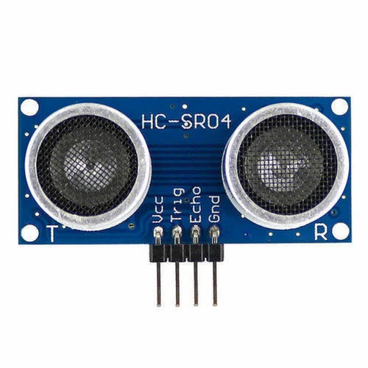

FIGURE 2: ULTRASONIC SENSOR

1. **DC Motor** : A machine that converts D.C power into mechanical power is known as a dc. motor. Its operation is based on the principle that when a current carrying conductor is placed in a magnetic field, the conductor experiences a mechanical force.

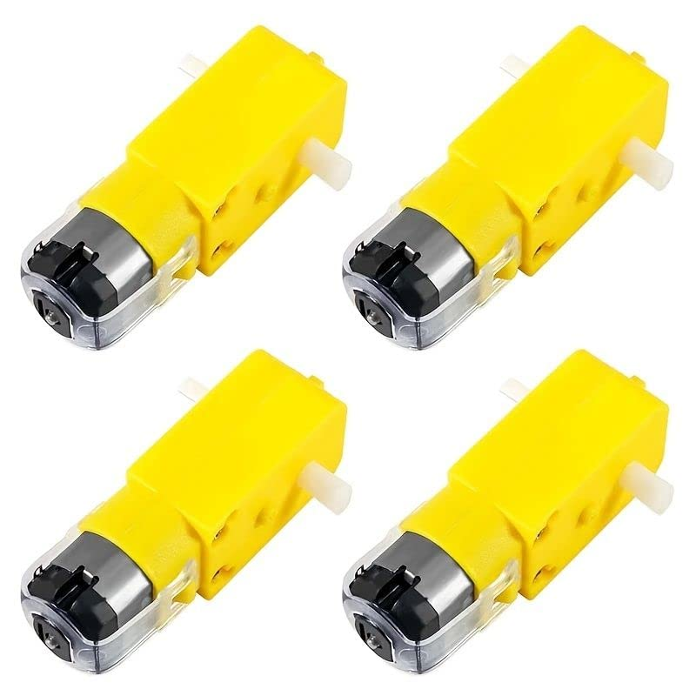

FIGURE 3: DC Motor

1. **Server Motor :** It is used to rotate the robot head (UDM sensor) from 45o to 135o back and forth (CW an CCW). Servo motor has 3 wire interfaces. (1) Vcc (2) Gnd (3) Signal. 5V supply from 7805 is given to Vcc. The servo motors turn to precise angular positions based on the input PWM duty-cycle. The ultrasonic sensors trigger after the servo reaches the angular position and waits to receive the echo. Once the echo is received the Arduino calculates the distance of the obstacle and then again rotates to the next angular position. This cycle occurs in every loop of the Arduino execution and consequently an obstacle map around the robot is generated using the proximities and distances of the obstacles sensed.

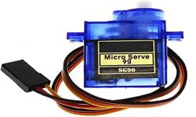

FIGURE 4: SERVO MOTOR

1. **Battery**: A rechargeable battery is an energy storage device that can be charged again after being discharged by applying DC current to its terminals. Rechargeable batteries allow for multiple usages from a cell, reducing waste and generally providing a better long-term investment in terms of dollars spent for usable device time. This is true even factoring in the higher purchase price of rechargeable and the requirement for a charger.

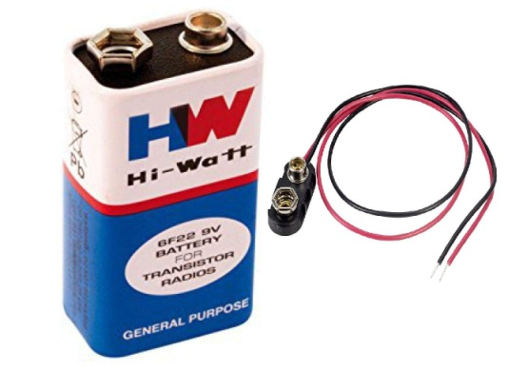

FIGURE 5: BATTERY

1. **Arduino** : The microcontroller used here is Arduino UNO. The UNO is a microcontroller board based on the ATMEGA 328P. The Atmega328 has 32 KB (Kilo Bytes) of flash memory for storing code. It has also 2 KB of SRAM (Static Random Access Memory) and 1 KB of EEPROM (Electrically Erasable Programmable Read-Only Memory). The board has 14 digital input/output pins, 6 analog inputs, a 16 MHz (Mega Hertz) quartz crystal, a USB, an ICSP circuit and a reset button. It contains everything needed to support the microcontroller. The UNO can be programmed with the Arduino soft with the Arduino Software.

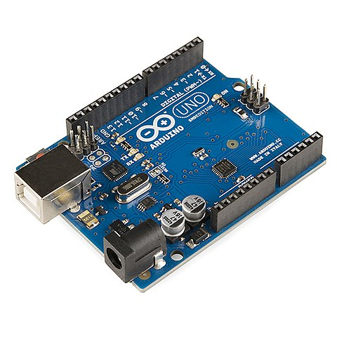

FIGURE 6: Arduino Uno

1. **Motor Driver**: Motor denotes the robot which can move over disaster prone areas. Motor drive is used for interfacing the microcontroller and robot. DC motors are used. DC motors have polarity and its rotation depends on direction of current. Since the DC motor requires much higher voltage and current, it cannot be interfaced directly with the microcontroller. Motor drive is used for this. It acts as an interfacing device to supply required power to the motor.

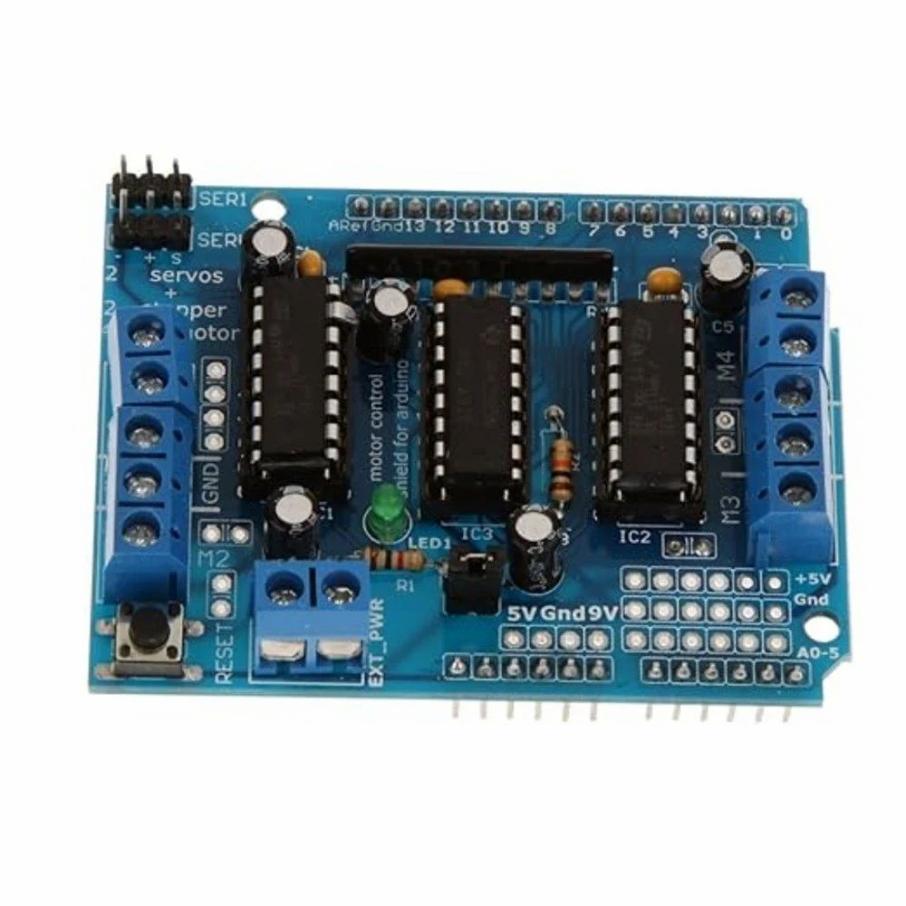

FIGURE 7 : MOTOR DRIVER

# CHAPTER 4. IMPLEMENTATION & RESULTS

* 1. HARDWARE:

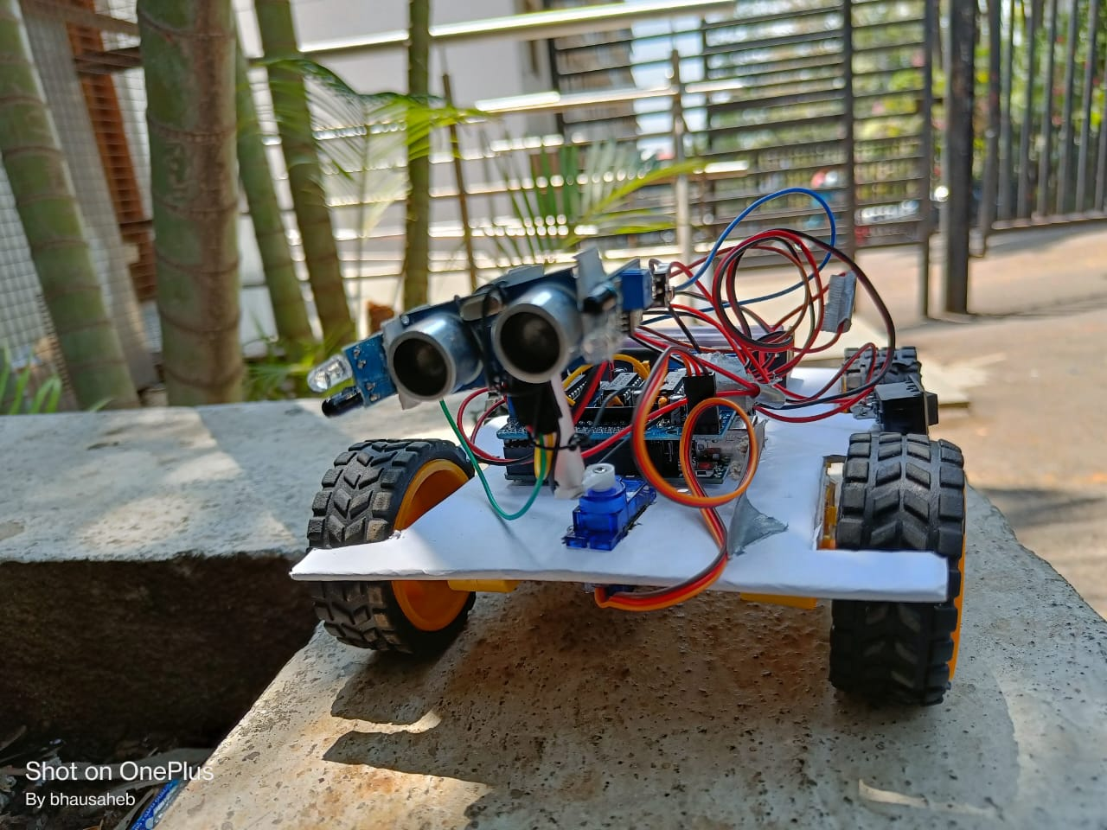

FIGURE 8: FINAL RESULT OF OBJECT TRACKING ROBOT

* 1. HARDWARE DETAILS:

Different experiments were conducted and the performance of the human following robot was tested. Each experiment that was performed took about 10 to 15 minutes. On the basis of results obtained from these tests and experiments, we made the necessary changes in the processing and control algorithm.

First test was performed on the ultrasonic sensor. It was noted that sensor was working accurately with in a range of 4 meters. Then we performed the test to check that weather the robot maintains a specific distance with target object. Initially the we set the stopping of robot to 8 inches. It was observed that robot collided with the object as the distance between robot and target object approaches to 8 inches. This problem behind this was that the stopping distance was small enough and robot was not stopping quickly because of its load on board. So we increased the distance to 12 inches. Then we again verified the routine.

The next test was performed on the magnetometer module. This module gave us the heading direction of the robot with respect to some reference. But we observed that there was some offset error in that heading direction. On observation we found that this was due to the wrong placement of the magnetometer module. This module was interfering with the magnetic field of the electronic components due to which we were getting the offset error. So we changed its placement and set it up at bottom layer and in the centre of the robotic structure. Now we had the heading degree without any offset error.

Then the next experiment was to test the detection of tag. We observed that in certain lightning conditions the tag was not detecting properly. So we adjusted the hue, saturation and value of all the four colours as colour thresholding in HSV varies by the lighting conditions. So after changing the threshold value we observed that this time the processor was detecting the Tag properly.

* 1. SUMMARY:

The primary application of this rescue robot is that it can be sent to different accident sites to search for victims in events of earth quake or building collapse. This Robot can also be programmed easily to aid the Fire Brigade team during a fire breakout or even by the Police force during any emergency hostile situation. A physically disabled person can also use this robot as an assistant if needed.

# CHAPTER 5. CONCLUSION

A successful implementation of an object tracking robot is illustrated in this research. This robot does not only have the detection capability but also the tracking and following ability as well. The tracking is basically performed on the tag and the object is followed on the basis of that detection. It was also kept in mind that the “following” capability of the robot should be as efficient as possible. The tests were performed on the different conditions to pin point the mistakes in the algorithm and correct them. The different sensors that were integrated with the robot added an additional advantage.

# CHAPTER 6. REFERENCE

1. K. Morioka, J.-H. Lee, and H. Hashimoto, “Human-following mobile robot in a distributed intelligent sensor network,” IEEE Trans. Ind. Electron., vol. 51, no. 1, pp. 229–237, Feb. 2004.[1]
2. Y. Matsumoto and A. Zelinsky, “Real-time face tracking system for human-robot interaction,” in 1999 IEEE International Conference on Systems, Man, and Cybernetics, 1999. IEEE SMC ’99 Conference Proceedings, 1999, vol. 2, pp. 830–835 vol.2.[2]
3. T. Yoshimi, M. Nishiyama, T. Sonoura, H. Nakamoto, S. Tokura, H. Sato, F. Ozaki, N. Matsuhira, and H. Mizoguchi, “Development of a Person Following Robot with Vision Based Target Detection,” in 2006IEEE/RSJ International Conference on Intelligent Robots and Systems, 2006, pp. 5286–5291.[3]
4. H. Takemura, N. Zentaro, and H. Mizoguchi, “Development of vision based person following module for mobile robots in/out door environment,” in 2009IEEE International Conference onRobotics and Biomimetics(ROBIO), 2009, pp. 1675–1680.[4]